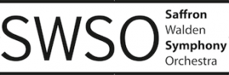

Feedback, Comments, Complaints and Compliments...
Please use this form to provide Saffron Walden Symphony Orchestra or Children’s Orchestra with your comments, compliments or complaints. You should download the form, complete it and email it to the current chair of the orchestral society at enquiries@saffronsymphony.org Alternatively, members of the orchestra may submit a printed copy to any member of the committee at a rehearsal.
We will acknowledge your comment by email within 5 working days. If you require a full response please answer ‘Yes’ to the question below. You will receive a response from a member of the SWOS within 2 weeks. Thank you for taking the time to share your comments.

Name:
(You may remain anonymous if you wish, but in this case we will not be able to provide you with a response)

Date:

Email address or other method of contact:

Are you making a comment, compliment or complaint?

Do you require a full response from a member of the SWOS committee?

Your feedback:

