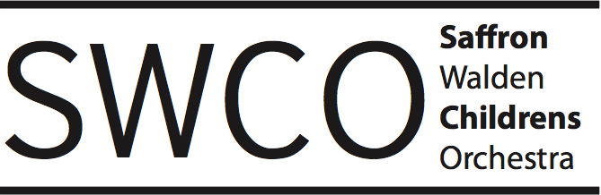
Booking Form for the Saffron Walden Children’s Orchestra (SWCO) EASTER Course 2023:
APRIL 4th-6th, 9.30 am - 12.30 pm at SAFFRON WALDEN COUNTY HIGH SCHOOL
Name of child | Age of child
School attended:
Instrument played: | Last exam taken and mark achieved:  If no exams taken, tutor book studied:
Instrumental teacher's name
Low brass players, please indicate whether you are a bass or treble clef reader
Name of parent / guardian:
Address:

Home / mobile phone number:
Email address:
Emergency contact:
Any known medical condition:
Doctor's name and address:
Name of person collecting your child each day:

Course T-shirt is included in the price – please indicate size: 7 – 8 / 9 – 11 / 12 – 13/adult M

Course fees per family (includes £5 family concert ticket):
One child: £80
Two children: £120
Three or more children: £140

If you consent to your email address being stored on our database, please sign/print below:
Signature:
Print name:

If you consent to photos being taken for publicity purposes, ie local news, facebook and our website please sign/print below:
Signature:
Print name:
If you have any queries, please contact Pippa Hopewell on: swco.bookings@gmail.com, mobile 07598 036295. Email or post completed application forms to: Pippa Hopewell, The White House, High Street, Great Chesterford, Essex CB10 1PL.
Please pay by bank transfer to Saffron Walden Orchestral Society :Account number 90850217, sort code 20-00-87. Please use your child’s name as the reference.

